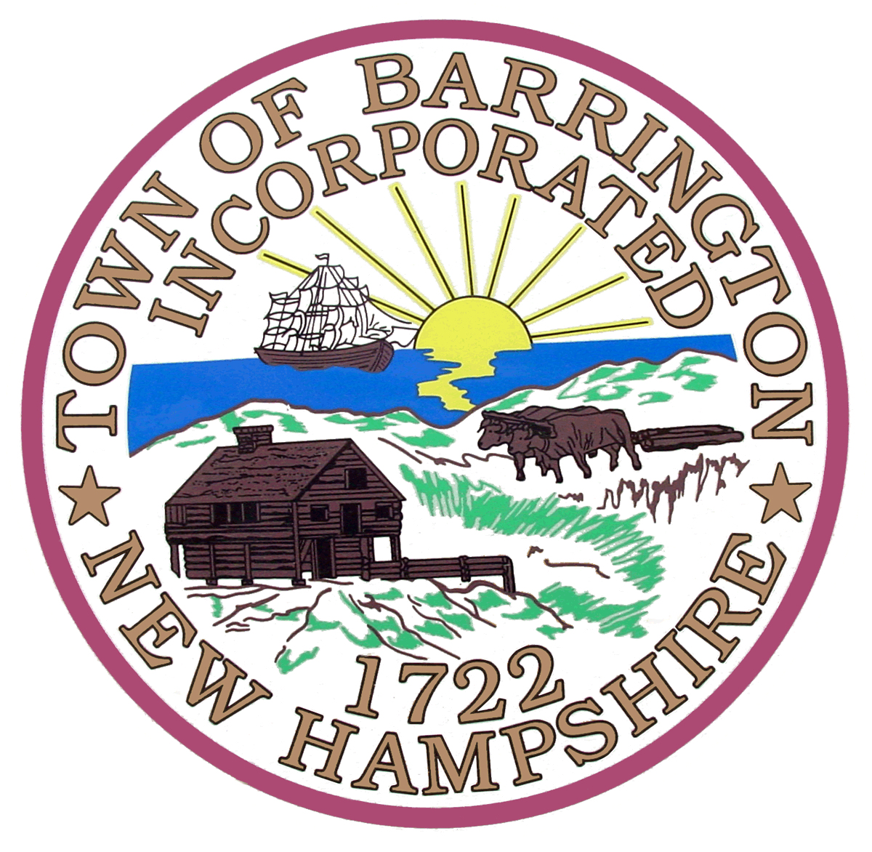

AGENDA

BARRINGTON PLANNING BOARD

And

CONSERVATION COMMISSION

SITE WALK

Map 260, Lot 20

267 Parker Mountain Road

Tuesday, July 16, 2013

6:00 p.m.

FOR THE FOLLOWING CASE:

260-20-GR/HCO-13-SP (Todd Calitri)Request by applicant for a Section 9.6 application for Special Permit for Construction in wetland buffer 1,000 s.f. to wetland buffer and 720 s.f. to Isinglass River overlay District to build an addition on the existing dwelling located at 267 Parker Mountain Road (Map 260, Lot 20) in the General Residential (GR) and Highway Commercial Overlay (HCO) Zoning Districts. By: Jason Pohopek; Pohopek Land Surveyors & Septic System Design, LLC; PO Box 651; Barrington, NH 03825